Project Design Phase-II
Technology Stack (Architecture & Stack)

Date | 07 September 2026
Team ID | SWUID2026190373
Project Name | ServiceNow Based Employee Laptop Request Application
Maximum Marks | 4 Marks

Technical Architecture:
The Deliverable shall include the architectural diagram as below and the information as per the table1 & table 2
Technical Architecture: Employee → ServiceNow Service Catalog → Record Producer → Laptop Request Form Table → Flow Designer → Manager Approval → Status Update → Email Notification → Request Tracking
Reference: https://developer.ibm.com/patterns/ai-powered-backend-system-for-order-processing-during-pandemics/
Guidelines:
Show the main ServiceNow processes and approval flow.
Separate Local users and ServiceNow Cloud.
Include Email notifications and data storage.
Machine Learning: Not Applicable.
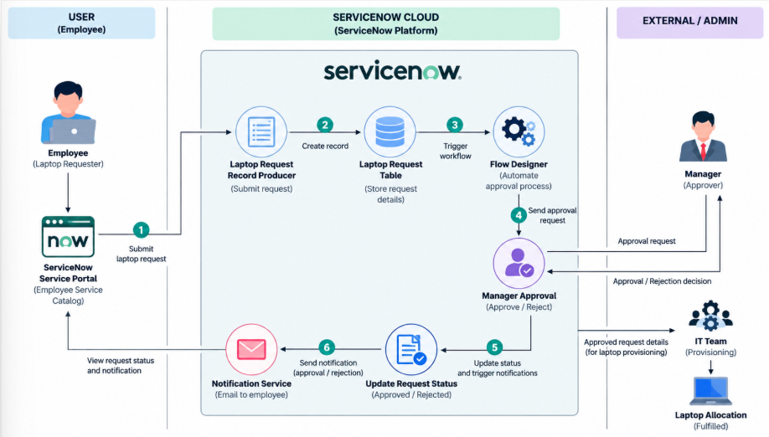

Table-1 : Components & Technologies:
S.No | Component | Description | Technology
1 | User Interface | Employee-facing catalog and request form interface. | ServiceNow Service Portal / Employee Center
2 | Catalog & Record Producer | Creates laptop request records from catalog variables. | ServiceNow Service Catalog and Record Producer
3 | Application Logic-1 | Stores and manages laptop request information. | Custom Table: u_laptop_request_form
4 | Application Logic-2 | Automates approval and request lifecycle. | ServiceNow Flow Designer
5 | Approval Management | Routes the request to the selected manager and records the decision. | ServiceNow Approvals / sysapproval_approver
6 | Email Notification | Sends request and decision notifications. | ServiceNow Notifications / Flow Designer
7 | Database | Stores request fields, statuses, and approval data. | ServiceNow Platform Database
8 | Security & Access | Controls who can create, approve, view, and manage requests. | ServiceNow Roles and ACLs
9 | External Interface | Uses ServiceNow user records and email services for routing and communication. | sys_user and Email Services
10 | Infrastructure (Cloud) | Hosts the application and automation. | ServiceNow Cloud Platform

Table-2: Application Characteristics:
S.No | Characteristics | Description | Technology
1 | Platform Framework | Built using native ServiceNow application and automation capabilities. | ServiceNow Service Catalog, Record Producer, Flow Designer
2 | Security Implementations | Access is controlled through authentication, roles, ACLs, and approval permissions. | ServiceNow Authentication, Roles, ACLs
3 | Scalable Architecture | Reusable catalog, table, and workflow components support growth in users and requests. | ServiceNow Cloud Platform
4 | Availability | The application uses managed cloud infrastructure provided by the ServiceNow platform. | ServiceNow Cloud Infrastructure
5 | Performance | Automation reduces manual processing and enables direct routing, updates, and notifications. | Flow Designer and Platform Services

References:
https://c4model.com/
https://developer.ibm.com/patterns/online-order-processing-system-during-pandemic/
https://www.ibm.com/cloud/architecture
https://aws.amazon.com/architecture
https://medium.com/the-internal-startup/how-to-draw-useful-technical-architecture-diagrams-2d20c9fda90d

Editable Technical Architecture Flow
Employee | Service Catalog | Record Producer | Laptop Request Table | Flow Designer
Manager Approval | Approval Decision | Status Update | Email Notification | Request Tracking

